Holi - The Festival of Colors

Holi is a joyous festival of Hindus. It is celebrated at the end of winter on Phalgun Purnima, the last full moon day of the lunar month Phalgun, which usually falls in March.
The festival has many purposes; most prominently, it celebrates the beginning of Spring.
It is a festival that celebrates agriculture, commemorated good spring harvests and the fertile land. Hindus believe it is a time of enjoying spring's abundant colors and saying farewell to winter. Holi festivities mark the beginning of new year, as well as a justification to renew friendships, reset old ruptured relationships, and take proactive steps to end conflicts and emotional impurities from the heart.
It also has a religious purpose, symbolically signified by the legend of destroying Holika (evil). The night before Holi, bonfires are lit, in a ceremony known as Holika Dahan (burning). People gather near fires, sing and dance. The next morning is a free-for-all carnival of colors, where participants play, chase and color each other with dry powder and colored water, with some carrying water guns and colored water-filled balloons for their water fight. Anyone and everyone is fair game, friend or stranger, rich or poor, man or woman, children and elders. The frolic and fight with colors occurs in the open streets, open parks, outside temples and buildings.
Children and youth enjoy the frolic with water guns and color filled balloons all around their neighborhood, laugh and celebrate, while elders playfully but respectfully greet and smear dry colored powder on each other's face.
After playing with colors, and cleaning up, people bathe, put on clean clothes, visit friends and family where they are served Holi specific food preparations, delicacies, desserts
and drinks. Groups carry drums and musical instruments, go from place to place, sing and dance. People visit family, friends and foes alike to socialize, laugh and chit-chat, then share Holi delicacies, food and drinks.

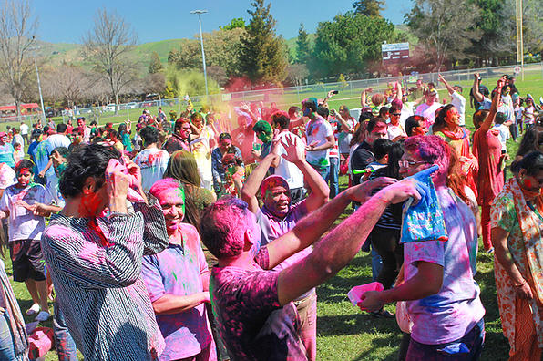

(extracted and edited from Wikipedia)

